Fate of germ layers
The embryonic germ layers are responsible for the formation of the organs of the body of the embryo in a process called organogenesis.
ectoderm | Mesoderm | endoderm
epidermis of skin  hair, nails, sweat glands  enamel of teeth  lining of nasal cavity, anus  nervous system, including brain  cornea, lens, retina of eye  adrenal medulla  posterior pituitary gland  portions of all sense organs | dermis of skin  all connective tissues  bone marrow  all muscle tissue  kidneys and ureters  testes and ovaries  adrenal cortex  lining of blood vessels  lymphatic tissue, vessels | mucosa of digestive tract  alveoli of lungs  tonsils  liver and pancreas  thyroid and parathyroid glands  lining of urinary bladder  lining of urethra, vagina  anterior pituitary gland  thymus gland

All the three germ layers will be subjected to a process of proliferation (mitosis) first ,which is followed by differentiation.
Ectoderm: The organ which are arising from the ectoderm are usually covering the surfaces of the body or lining part of the oral cavity and final part of the anal canal. In many places the ectoderm shared with either the mesoderm or endoderm to form the organs in the body.
Example: The epidermis of skin has come from ectoderm; while the dermis is from mesoderm. The anterior one third of dorsal surface of tongue is from the ectoderm while posterior one third is covered by epithelial of endodermal origin.
Mesenchyme is embryonic connective tissue that is derived from the mesoderm and that differentiates into hematopoietic and connective tissue, whereas MSCs do not differentiate into hematopoietic cells.

Neural Crest:
Also during the third week, another specialized group of cells, the neural crest cells, develop from the neuroectoderm. These cells are differentiated and separated from the dorsolateral aspect of the neural tube .
Origin: These cells are originating from neuroectoderm during development of the CNS.
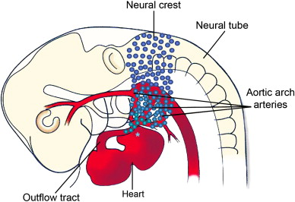

The neural crest cells migrate away from the neuroectoderm in a form of waves.
The migrations are initiated at about 4 week in human embryo. These migrated cells have the capacity to differentiate extensively within the developing embryo to form many structures and cells in the head and neck and other parts of the body, including the branchial arches and their derivatives. On reaching their predetermined destination, the neural crest cells undergo differentiation into diverse cells types. Embryonic connective tissue elsewhere is derived from mesoderm and is known as mesenchyme, whereas in the head it is known as ectomesenchyme, reflecting its origin from neuroectoderm. Because of this pluripotency they have sometimes been referred to as the fourth germ layer. There is virtually not a single organ or tissue in the vertebrate body to which cells from the neural crest do not contribute.

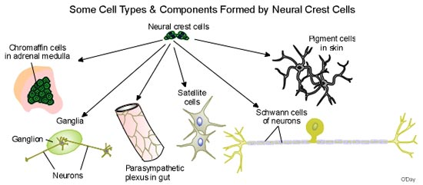

Nutrition of the embryo:
Two principal pathways have evolved to transfer nutrients from the mother to her fetus. These are termed histotrophic and haemotrophic, respectively.
- Before implantation:
Before implantation, nutrition of the mammalian conceptus is therefore essentially histotrophic. Histiotroph is an extracellular material derived from the endometrium and the uterine glands that accumulates in the space between the maternal and fetal tissues. It is phagocytosed initially by the trophoblast of the blastocyst, and later by the trophoblast of the placenta.
- After implantation:
By contrast, haemotrophic nutrition is the exchange of blood-borne materials between the maternal and fetal circulations. This is facilitated by the extensive and intimate apposition of the maternal and fetal tissues that occurs within the placenta. Once the placenta is established, haemotrophic nutrition becomes predominant. After implantation the external layer of the blastocyst which is named as trophoblast starts to proliferate. Some of these proliferating cells lose their membranes and coalesce to form syncytium (a mass of cytoplasm containing numerous dispersed nuclei) called syncytiotrophoblast.
By contrast the cells of the trophoblast that line the wall of the blastocyst retain their cell membranes and constitute the cytotrophoblast.
When the embryo becomes fully implanted in the endometrium, proteolytic enzymes, including several metalloproteinases, are secreted by cytotrophoblast to break down the extracellular matrix between the endometrial cells. Finger like processes extending from the syncytitrophoblast then penetrate between the separating endometrial cells and pull the embryo deep into endometrium.
Establishment of uteroplacental circulation:
For the establishment of haemotrophic type of nutrition which is essential to cover the demands of growing embryo. This needs an efficient way of exchange of materials between the mother and embryo by uteroplacental circulation. This requires a system of maternal and fetal blood flowing through placenta come into close proximity. This system starts to be formed during the second week. When the syncytitrophoblast processes extended deep into the endometrium they become close to the expanded maternal capillaries. The syncytiotrophblast starts eroding the endothelial lining of the expanded and congested maternal capillaries. Thus maternal blood begins to flow to establish haemotrophic nutrition which marks the beginning of uteroplacental circulation. At the same time the cytotrophoblast proliferates locally to form extensions that grow into overlying syncytiotrophblast. The resulting outgrowths are called primary chorionic villi.
The syncytiotrophoblast secretes progesterone and human chorionic gonadotropin (hCG) ; hCG prevents degeneration of the luteum. The hCG hormone is used as a test of early pregnancy (could be detected after two weeks in the blood ,and four weeks in the urine of pregnant woman). Progesterone serves to maintain the integrity of the uterine lining and, until the syncytiotrophoblast is mature enough to secrete enough progesterone to support pregnancy (in the fourth month of embryonic development), it is aided by the corpus luteum of pregnancy.
After implantation the trophoblastic layer(could be called as cytotrophoblast) which was forming the outer covering layer for the blastocyst give rise after proliferation to a mass of multi nuclear layer cytoplasm without cell boundaries called syncytiotrophoblast. The syncytiotrophoblast is now forming an outer covering layer to the blastocyst; overlying the cytotrophoblast.
The syncytiotrophoblast forms a syncytium, i.e., a multi-nucleic layer without cell boundaries that arises from the fusion of cytotrophoblast cells. The syncytiotrophoblast produces lytic enzymes and secretes factors that cause apoptosis of the endometrial epithelial cells. The syncytiotrophoblast also crosses the basal lamina and penetrates into the stroma that lies below, eroding the wall of capillaries. With the implantation of the blastocyst in the endometrium the syncytiotrophoblast develops quickly and will entirely surround the embryo as soon as it has completely embedded itself in the endometrium. The syncytiotrophoblast plays an important role in fetal-maternal gas exchange, nutrient exchange, and immunological and metabolic functions.

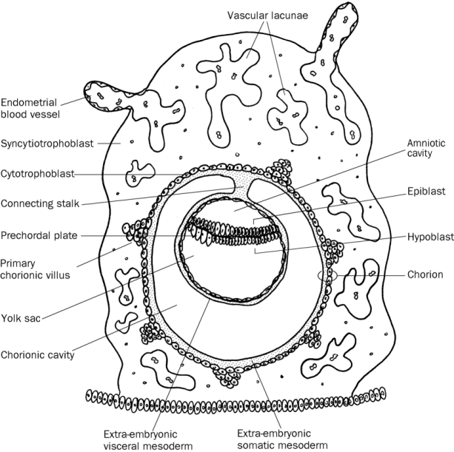

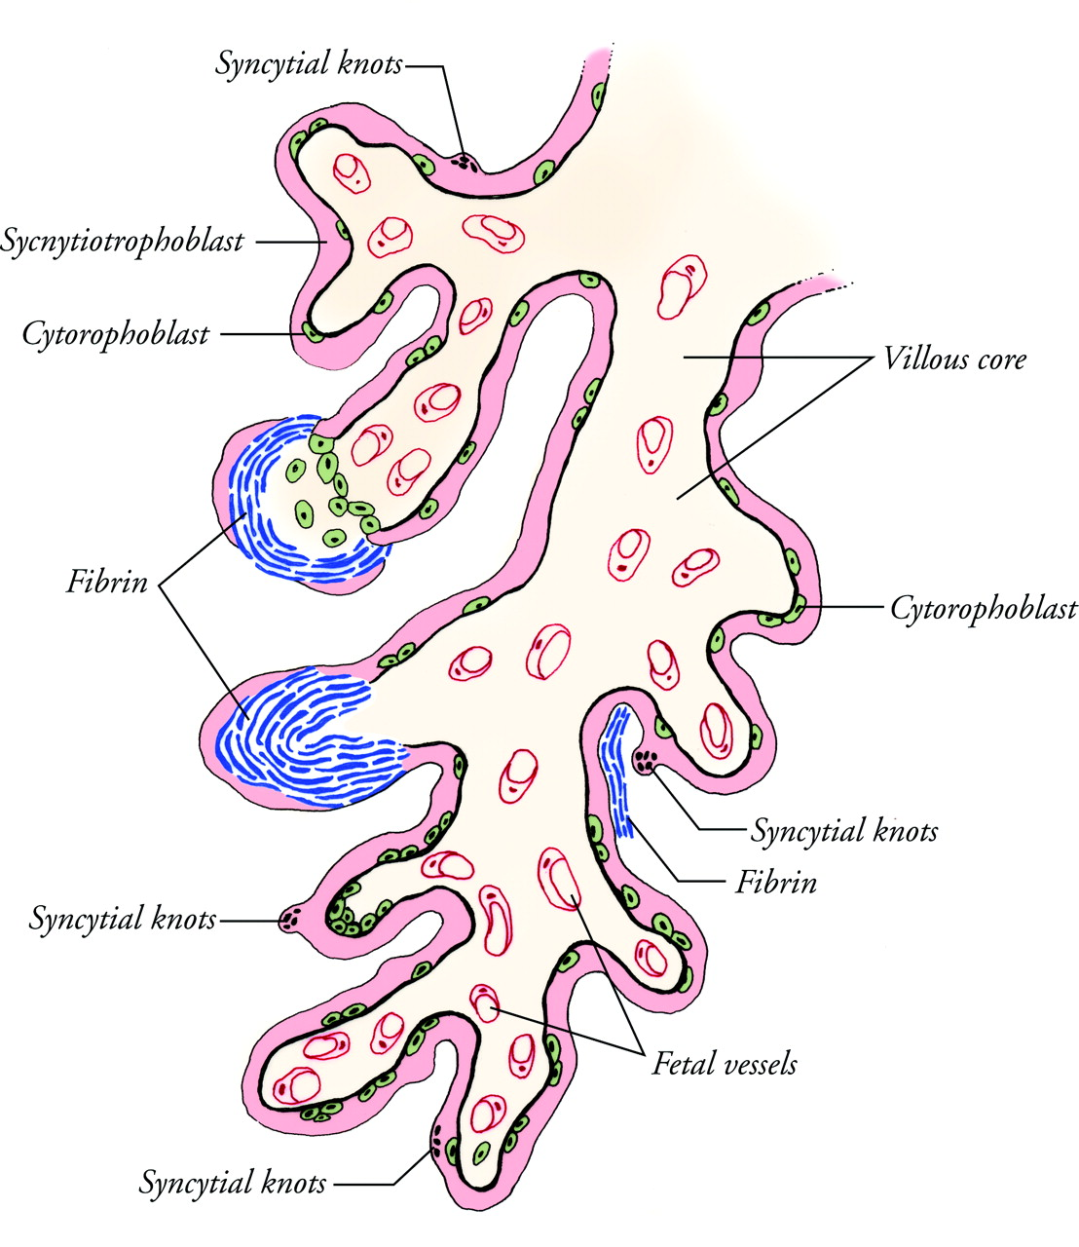

Placenta
The placenta is derived from both fetal and maternal cells. The placenta first takes shape when cells from the fetus, called trophoblasts, attach to the uterus wall and then proceed to invade the tissues of the uterus. They eventually reach deep into the wall and connect with the mother's blood vessels. As the placenta continues to develop, a network is formed of finger-like projections, called villi, which project into spaces, or lacunae, that fill up with the mother's blood. At this time the baby's circulatory system is developing, and fetal blood vessels form in the placental villi. These vessels connect back to the baby via blood vessels traveling through the umbilical cord, which attaches the baby to the placenta. Gas and nutrient exchange and waste removal take place across the villis' walls, which also serve to keep the baby's blood from mixing with the mother's blood.
The placenta is a unique vascular organ that receives blood supplies from both the maternal and the fetal systems and thus has two separate circulatory systems for blood: (1) the maternal-placental (uteroplacental) blood circulation, and (2) the fetal-placental (fetoplacental) blood circulation.
The placenta also functions as an endocrine organ, meaning it releases hormones, which enable both the mother and baby to have a successful pregnancy. Some of these, such as progesterone, help to maintain the pregnancy, while others increase the maternal blood supply to the fetus, others may increase the amount of glucose in the mother’s blood, and still others help to prepare both the baby and the mother for delivery. After the safe delivery of the baby, the placenta is delivered. Often the placenta is referred to as the "afterbirth" for this reason. The umbilical cord is clamped and cut, and the site of attachment on the baby is commonly known as the umbilicus, navel or belly-button.
