DEVELOPMENT OF THE NERVOUS SYSTEM

The nervous system develops from the neural plate, a thickened area of embryonic ectoderm. It is the notochord and paraxial mesenchyme that induce the overlying ectoderm to differentiate into the neural plate. The human brain begins forming very early in prenatal life (just three weeks after conception), but in many ways, brain development is a lifelong project.
The nervous system is derived exclusively from cells of the ectoderm.

- The neural tube differentiates into the CNS, consisting of the brain and spinal cord.
- The neural crest gives rise to cells that form most of the PNS and ANS, consisting of cranial, spinal, and autonomic ganglia, Schwann cells, and many other structures. 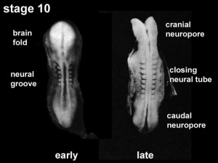
This figure is showing the neural groove closing to neural tube, early week 4.
Neural development is one of the earliest systems to begin and the last to be completed after birth. This development generates the most complex structure within the embryo and the long time period of development means in utero insult during pregnancy may have consequences to development of the nervous system. The most anterior vesicle or cavity is called the forebrain or prosencephalon, the second is the midbrain or mesencephalon, and finally the caudal one is the hindbrain or rhombencephalon. By five weeks the development of the CNS is said to be in a five vesicle stage, since the forebrain and hindbrain have subdivided each in two. These divisions are considered the last series of subdivision of the nervous system during development.

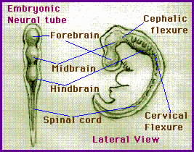
1.Fore brain(prosencephalon)divides into :a. Telencephalon which will gives rise into cerebral hemisphere. b.diencephalon which gives rise to thalamus,hypothalamus.
2. Mesencephalon: mid brain.
3. Rhombencephaon (hind brain) :Is divided into :
a. Metencephalon:gives rise to pons and cerebellum.The cerebellum controle posture,balance and movement .
b. Myelencephalon(medulla oblongata
The caudal segment form the spinal cord.
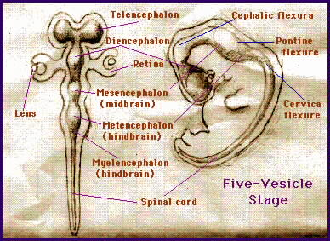
Between three to seven months all brain structures and nuclei will be differentiated. From the telencephalon derive the cerebral cortex, basal ganglia, hippocampal formation, amygdala and olfactory bulb. From the diencephalon the thalamus and surrounding nuclei, hypothalamus, retina and optic nerve.
(N.B: Nuclei are aggregation of neurons inside the CNS).
The mesencephalon gives rise to the midbrain structures, and the metencephalon the pons and cerebellum. The myelencephalon derives in the medulla. The caudal part of the neural tube develops and differentiates into the spinal cord.
Which plays a more important role in brain development, nature (genes) or nurture (environment)?
Genes and environment interact at every step of brain development, but they play very different roles.
Does experience change the actual structure of the brain?
Yes. Brain development is "activity-dependent," meaning that the electrical activity in every circuit—sensory, motor, emotional, cognitive--shapes the way that circuit gets put together.
How does nutrition affect the developing brain?
Brain development is most sensitive to a baby's nutrition between mid-gestation and two years of age.

Neurulation-formation of the neural plate and neural tube-begins during stage 10 of development (22-23 days) in the region of the fourth to sixth pairs of somites. At this stage, the cranial two thirds of the neural plate and tube, as far caudal as the fourth pair of somites, represent the future brain, and the caudal one third of the neural plate and tube represents the future spinal cord. Fusion of the neural folds and formation of the neural tube proceeds in cranial and caudal directions until only small areas of the tube remain open at both ends. Here the lumen of the neural tube-neural canal-communicates freely with the amniotic cavity. The cranial opening, the rostral neuropore, closes on approximately the 25th day and the caudal neuropore 2 days later. Closure of the neuropores coincides with the establishment of a blood vascular circulation for the neural tube. The walls of the neural tube thicken to form the brain and the spinal cord. The neural canal forms the ventricular system of the brain and the central canal of the spinal cord.

DEVELOPMENT OF THE SPINAL CORD

The neural tube caudal to the fourth pair of somites develops into the spinal cord .
The lateral walls of the neural tube thicken, gradually reducing the size of the neural canal until only a minute central canal of the spinal cord is present at 9 to 10 weeks .
Within the neural tube stem cells generate the 2 major classes of cells that make the majority of the nervous system : neurons and neuroglial cells. Both these classes of cells differentiate into many different types generated with highly specialized functions and shapes. The cells that constitute the neural tube (formerly the neural plate) are going to give rise to the neurons of the central nervous system, astrocytes and oligodendrocytes, whereas the cells of the neural crest will give rise to ganglionic neurons, meningeal cells and Schwann cells.

Initially, the wall of the neural tube is composed of a thick, pseudostratified, columnar neuroepithelium . These neuroepithelial cells constitute the ventricular zone (ependymal layer), which gives rise to all neurons and macroglial cells (macroglia) in the spinal cord . Macroglial cells are the larger members of the neuroglial family of cells, which includes astrocytes and oligodendrocytes. Soon a marginal zone composed of the outer parts of the neuroepithelial cells becomes recognizable. This zone gradually becomes the white matter (substance) of the spinal cord as axons grow into it from nerve cell bodies in the spinal cord, spinal ganglia, and brain. Some dividing neuroepithelial cells in the ventricular zone differentiate into primordial neurons-neuroblasts. These embryonic cells form an intermediate zone (mantle layer) between the ventricular and marginal zones. Neuroblasts become neurons as they develop cytoplasmic processes.

The primordial supporting cells of the central nervous system-glioblasts (spongioblasts)-differentiate from neuroepithelial cells, mainly after neuroblast formation has ceased. The glioblasts migrate from the ventricular zone into the intermediate and marginal zones. Some glioblasts become astroblasts and later astrocytes, whereas others become oligodendroblasts and eventually oligodendrocytes. When the neuroepithelial cells cease producing neuroblasts and glioblasts, they differentiate into ependymal cells, which form the ependyma (ependymal epithelium) lining the central canal of the spinal cord.

Microglial cells (microglia), which are scattered throughout the gray and white matter, are small cells that are derived from mesenchymal cells . Microglial cells invade the CNS rather late in the fetal period after it has been penetrated by blood vessels. Microglia originate in the bone marrow and are part of the mononuclear phagocytic cell population.

Summary of CNS development
- Timing
Begin at the third week of IU period.

- Histogenesis of the neural tube is the origin of neurons and neuroglial cells . The neuroepithelial cells of the neural tube
first give rise to neuroblasts which give rise to the neurons.
Neuroglial cells arise from neuroepithelial cells which give rise to gliablasts after production of neuroblasts has ceased.
Microglial arise from mesoderm.Ependymal cells lining neural canal are last to differentiate.

Clinical consederation:
Spina bifida: Spina bifida (Latin: "split spine") is a developmental congenital disorder caused by the incomplete closing of the embryonic neural tube. Some vertebrae overlying the spinal cord are not fully formed and remain unfused and open.
Classification:

1. Spina bifida occulta
In occulta, the outer part of some of the vertebrae is not completely closed. The skin at the site of the lesion may be normal, or it may have some hair growing from it.

2. Meningocele
In a posterior meningocele, the vertebrae develop normally, however the meninges are forced into the gaps between the vertebrae.

3. Myelomeningocele
This type of spina bifida is the most common and often results in the most severe complications. In individuals with myelomeningocele, the unfused portion of the spinal column allows the spinal cord to protrude through an opening. In this type the backbone and spinal canal do not close before birth. In severe cases, this can result in the spinal cord and its covering membranes protruding out of an affected infant's back.
